EXP-28:

Aim: Design DFA using simulator to accept the string the end with ab over set {a,b)

W= abbaabab.

Diagram:

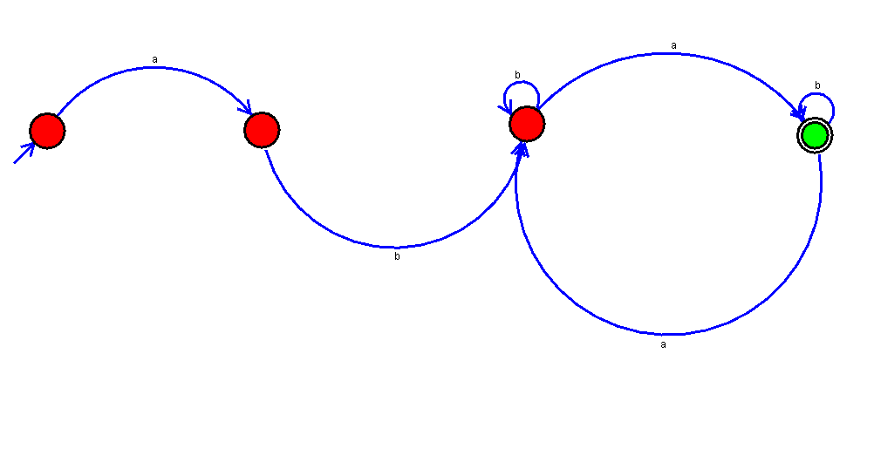

Result:

Successfully executed DFA using simulator to accept the string the end with ab over set {a,b) W= abbaabab.